HW 4-5 Sols

Part1
Rosen -Do the shaded problems from the pdf Rosen-HW 4-5. This material is from the 7th ed and are at the end of sections 3.1 and 3.3

3.1
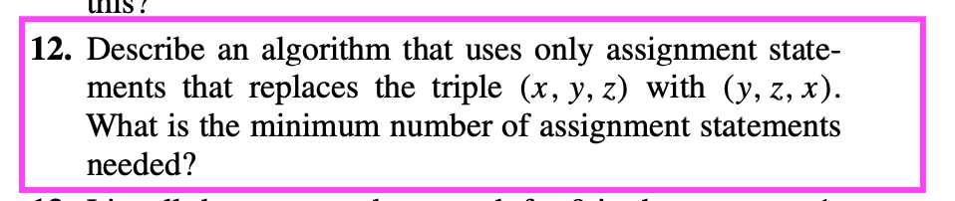
Surpirisingly only 4:

savex=x
x=y
y=z
z=savex

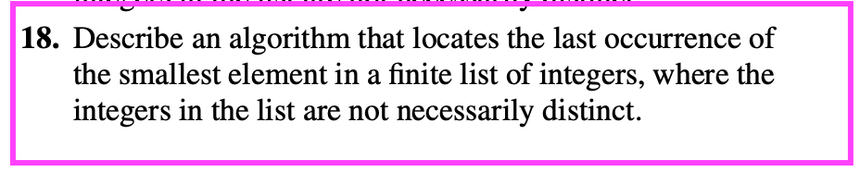

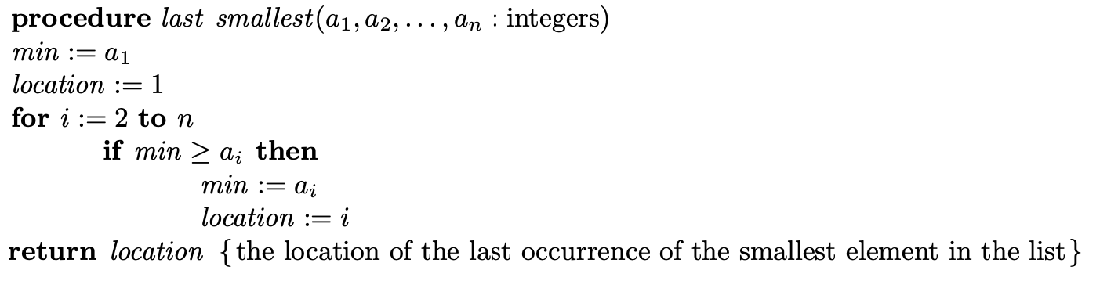
_________________________________________________

Rosen 3.3
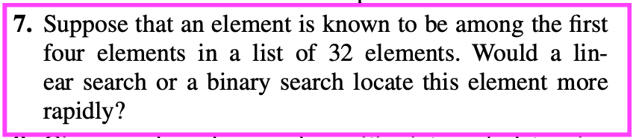

Linear

r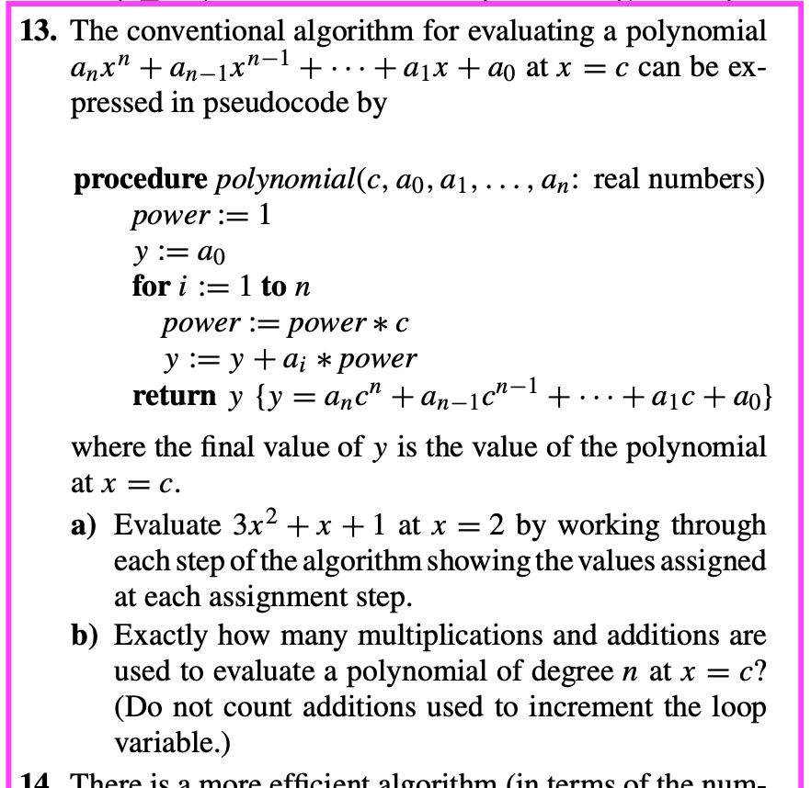

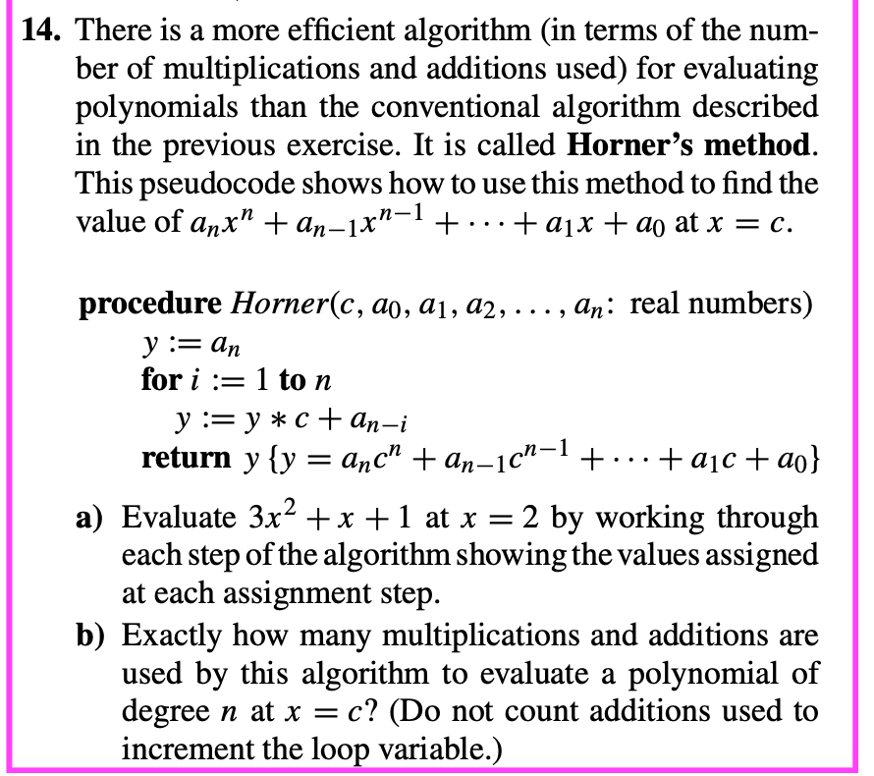

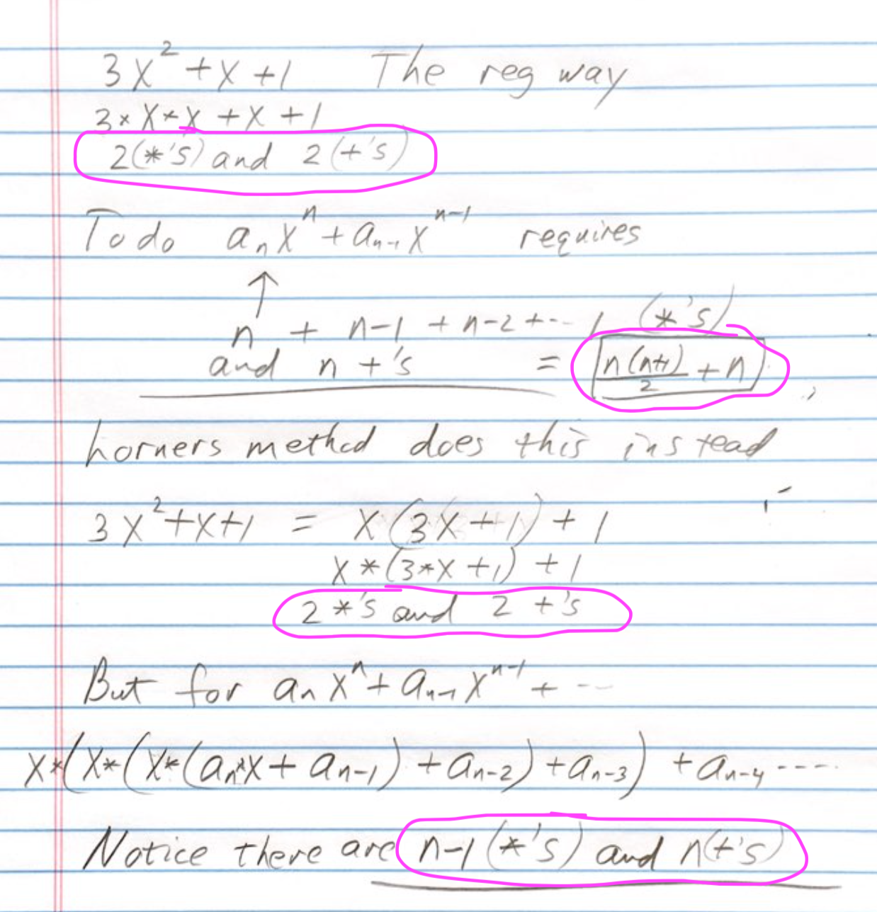

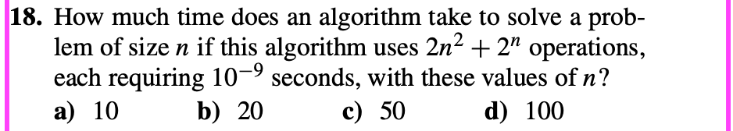

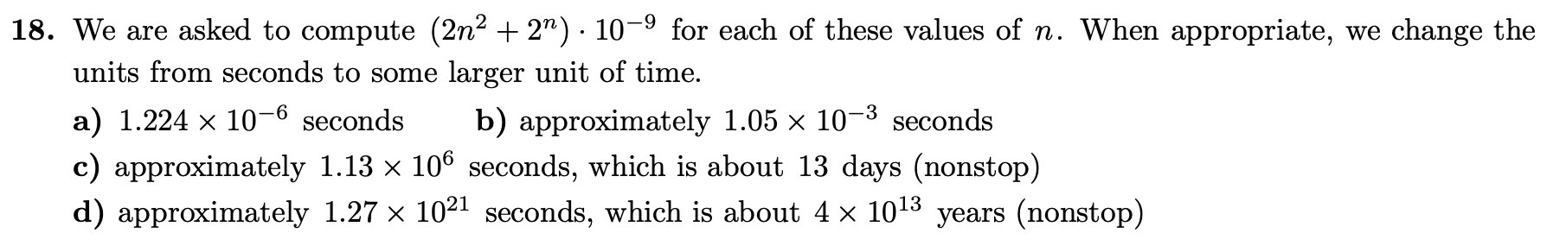

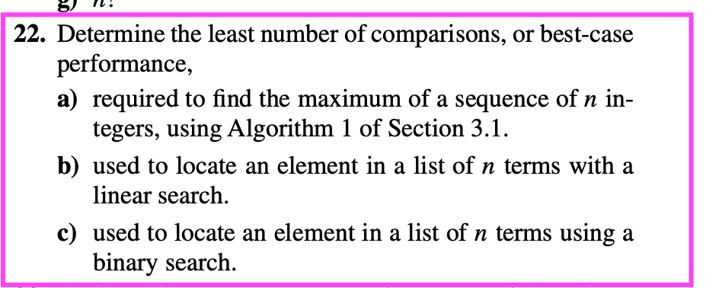

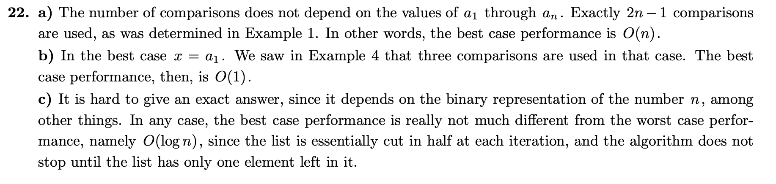
Bubble Sort
a) Consider the array A = [3,7,4,1,8,5,6,2].
Write down the first pass through the array using Bubble sort showing the array at each step.
[3, 4, 7, 1, 8, 5, 6, 2]
[3, 4, 1, 7, 8, 5, 6, 2]
[3, 4, 1, 7, 5, 8, 6, 2]
[3, 4, 1, 7, 5, 6, 8, 2]
[3, 4, 1, 7, 5, 6, 2, 8]

b) " " " second pass " "
[3, 1, 4, 7, 5, 6, 2, 8]
[3, 1, 4, 5, 7, 6, 2, 8]
[3, 1, 4, 5, 6, 7, 2, 8]
[3, 1, 4, 5, 6, 2, 7, 8]
c) How many comparisons need to be made in order to finally sort it?
7+6+5+..+2+1=28 formula is n*(n+1)/2 = 7*(8)/2
d) How many comparisons need to be made in order to sort an array of size n?
(n-1)*n/2
e) What is the complexity of Bubble sort in terms of an array of size n?
O(n**2)

Part2

Program 1 write a program that reverses the elements in an array from index left to index right.
Please use elementary assignment statements ie no special methods
Qualification: Your chip has very limited memory so you do not have the memory to create a new array to store the reversed values. You must overwrite the original array.

Can use the reverse method in prog 2 below with left =0, right = len(A)

Program 2 Write a function wrap_by_k ( lst, k) that wraps an array lst around by k values.
so if lst = [1, 2, 3, 4, 5, 6, 7, 8] wrap_by_k(lst, 3) returns [6, 7, 8, 1, 2, 3, 4, 5]
Qualification: You do not have the memory to create a new array-the wrapping must be done in the original array.

A=[0,1,2,3,4,5,6,7,8]
print(A)

# reverse the values of A between index left and right
def reverse(A,left,right):
diff=(right-left)//2+1
for i in range(diff):
A[left+i],A[right-i]=A[right-i],A[left+i]
def wrap_by_k(A,k):
#reverse the last k elements
reverse(A,len(A)-k,len(A)-1)

#reverse the first part of the array
reverse(A,0,len(A)-k-1)

#reverse the entire array
reverse(A,0,len(A)-1)

wrap_by_k(A,3)
print(A)

Program 3 How many 0's are at the end of 100! That's 100 factorial not 100 with an exclamation! Do this without calculating 100! Write an efficient general method that determines the number of 0's at the end of n!. For instance 10! = 3,628,800 has 2. (Hint: what are the only ways for there to be a factor of 10?
def fives(n):
# find # 5 factors in a number n
count=0 #number of 5 factors found
while n % 5==0:
n = n//5
count += 1
return count

# Find the number of zeroes by calculating the number of 5's
def num_zeroes(n):
num_0s=0
for i in range(5,n+1,5):
num_0s += fives(i)
return num_0s

print(num_zeroes(100))
Program 4 Write a program that does the bubble sort. Demonstrate its complexity by empirically calculating the time to execute for arrays of various sizes and describe the differences in terms of complexity. State your results in complete sentences. Some useful commands:
- def bubble(lst):
- n=len(lst)
- for j in range(n-1):
- for i in range(n-1-j):
- if lst[i+1] < lst[i]:
- lst[i+1],lst[i]=lst[i],lst[i+1]
- if j==1 :
- print(lst)

Should find O(n**2) complexity-should try sufficiently larg array sizes ie n=10^4, 10^5, etc or 2^20, 2^21 etc I like powers of 2 myself for something that is O(n^2) since 100 times longer is too long to wait.

